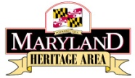
Interested in applying for an
FY25 MHAA Project Grant?
Have online application questions?
Contact Olivia Peterson, Heritage Area Assistant: olivia@heartofthecivilwar.org

